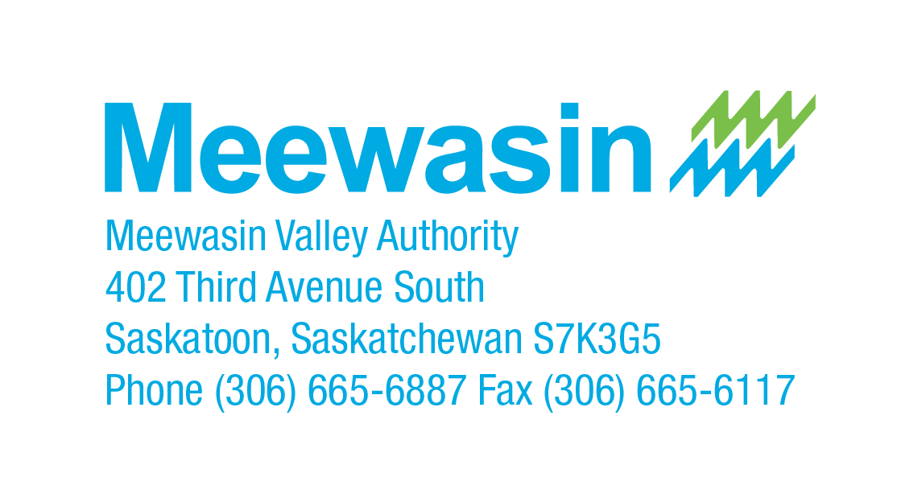

NEWS RELEASE for immediate release

Meewasin is Thinking Local to Act on Global Goals
January 16, 2023
There is a new Kunming-Montreal Global Biodiversity Framework (GBF) and Meewasin is perfectly aligned to continue contributing to a healthier planet.
The United Nations Biodiversity Conference (COP15) ended in Montreal, on 19 December 2022 with a landmark agreement to guide global action on nature through to 2030. Representatives from 188 governments gathered in Montreal for two weeks to discuss conservation and biodiversity loss. With the event being held in Canada there was a unique opportunity to highlight the best conservation success stories the country has to offer. Meewasin is one of these successes and our representatives were humbled to be included as presenters to attendees of the conference.
The GBF aims to address biodiversity loss, restore ecosystems and protect indigenous rights. The plan includes concrete measures to halt and reverse nature loss, including putting 30 per cent of the planet and 30 per cent of degraded ecosystems under protection by 2030. This framework is a stepping stone towards the GBF 2050: Vision of “Living in harmony with nature”. This vision has many commonalities with the Meewasin 100 year concept plan, which was written in 1978 and much ahead of its time. Balancing human use and conservation is not for the faint of heart and Meewasin makes tough decisions with participation from many parties about how to do this by taking a very long-term view.
“Meewasin is very locally focused; taking care of the Meewasin Valley and connected green spaces for future generations is our first priority. To be recognized nationally and internationally for our region’s vision and execution on sustainable planning, accessible green spaces and conservation in an urban setting was incredible. In many ways our region is leading the way and we are so proud to do this work on behalf of local ecosystems but more importantly on behalf of the planet,” explains Andrea Lafond. The opportunity to attend such an important event with other organizations and governments has expanded Meewasin’s partnerships and provided new opportunities for global collaboration.

The framework includes four goals and 23 action-oriented global targets for urgent action over the decade to 2030. Many of these goals directly overlap with Meewasin’s mission and current goals and objectives.
Read the full Global Biodiversity Framework document HERE

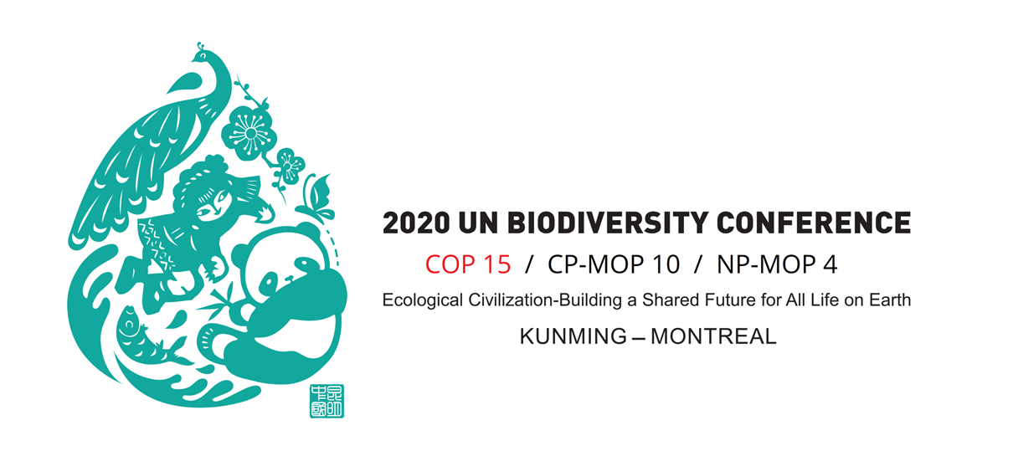

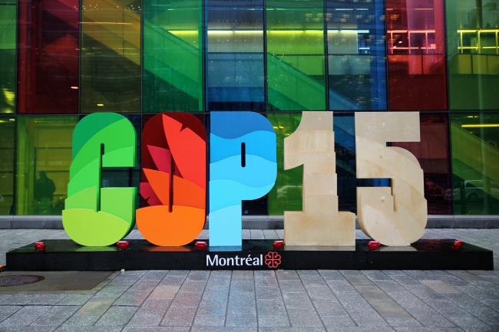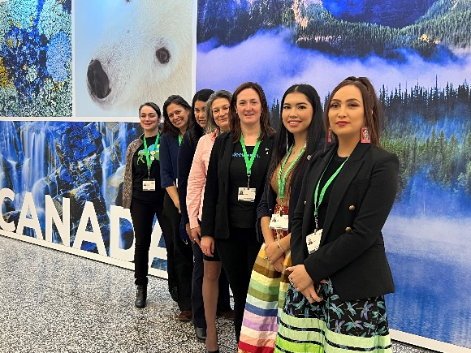

For more information, contact Andrea Lafond at (306) 665-6887 or meewasin@meewasin.com

-30-

About Meewasin Valley Authority
The Meewasin Valley Authority exists to ensure a healthy and vibrant river valley, with a balance between human use and conservation by:

- Providing leadership in the management of its resources;
- Promoting understanding, conservation and beneficial use of the Valley; and
- Undertaking programs and projects in river valley development and conservation,

for the benefit of present and future generations.

There are 67 square kilometers of land and more than 105km of established trail, which has seen up to 2.24 million trail visits per year, in the Meewasin Valley. The area also features sites that help people to connect to nature through experiences such as Beaver Creek Conservation Area, the Northeast Swale, Saskatoon Natural Grasslands, the River Landing Spray Area, and the Cameco Meewasin Skating Rink @Nutrien Plaza. Meewasin is a non-profit organization that relies on donations and volunteers for sustainability. To get involved or learn more visit www.meewasin.com

