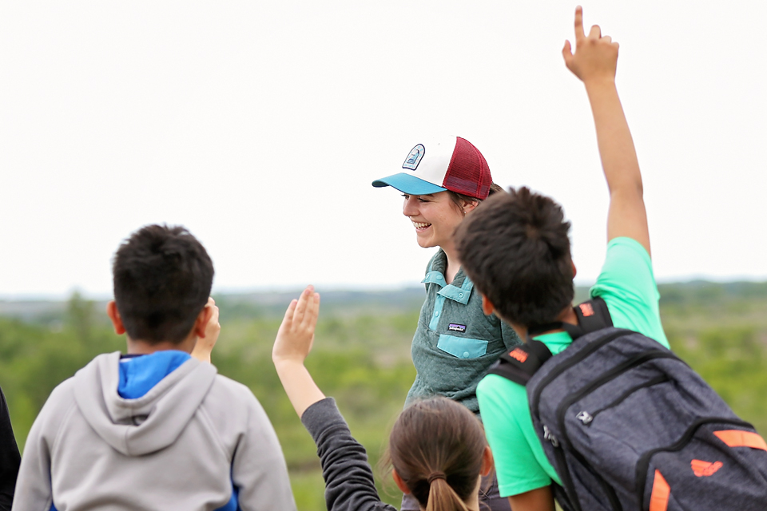

Environmental Education Programming in the Meewasin Valley



Meewasin Valley Authority
402 Third Avenue South
Saskatoon, SK S7K 3G5
306-665-6887 meewasin.com
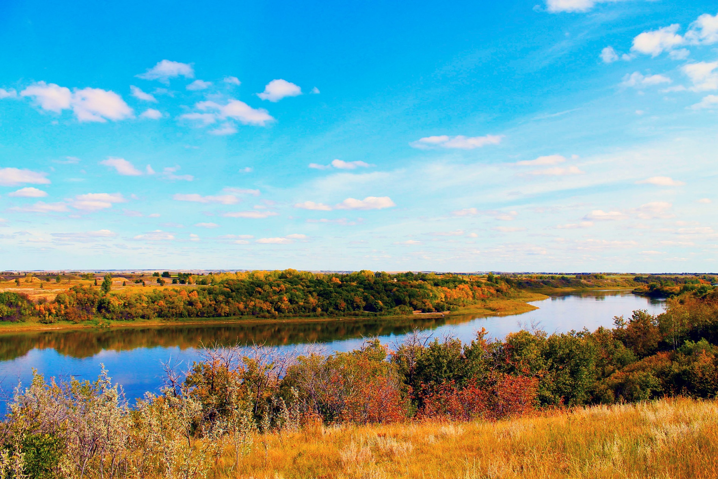

Meewasin Environmental Education Programming in the Meewasin Valley.

The Meewasin Environmental Education Program Boxes contain thematic material about the natural environment of the Meewasin Valley and specific information about the following key sites: Beaver Creek Conservation Area, Saskatoon Natural Grasslands, and the Northeast Swale. Program content profiles Meewasin as the steward of the Valley and the ecological characteristics of these natural areas and the adaptations of their related flora and fauna. It also dives into further details of how Meewasin works hard throughout the Valley to maintain the health, fit, and balance to everything within it.

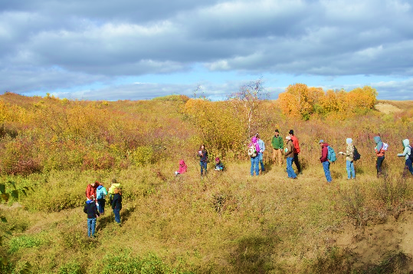

Beaver Creek Conservation Area

- Natural area description
- Primary subjects (fields) of exploration and discovery
- location

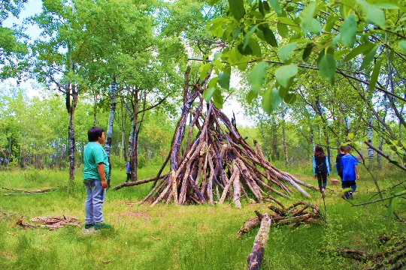

Saskatoon Natural Grasslands

- Natural area description
- Primary subjects (fields) of exploration and discovery
- location

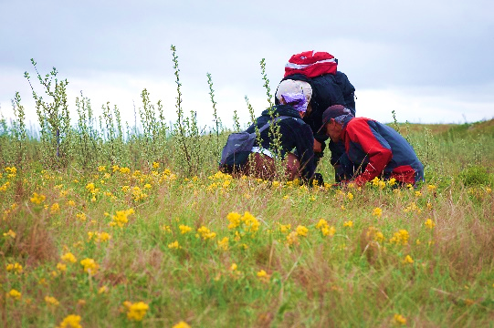

Northeast Swale

- Natural area description
- Primary subjects (fields) of exploration and discovery
- location

A Green Space Near You!

Saskatoon Natural Areas Inventory Report

Using the out-of-doors as a natural classroom can take many forms. It can be as simple as growing plants on a windowsill in a classroom. From school grounds, city parks, and the Meewasin Trail opportunities to explore, discover, and experience the living world and people’s interactions with it are readily available. Getting outside does not require the capacity to drive distances to undeveloped forests. All you need are sensible shoes and a map of Saskatoon.

The Natural Areas Inventory Report shows that 99% of Saskatoon residents live within a 5 to 10 minute walk of an urban green space and 82% of residents are within a 5 minutes' walk to green space.
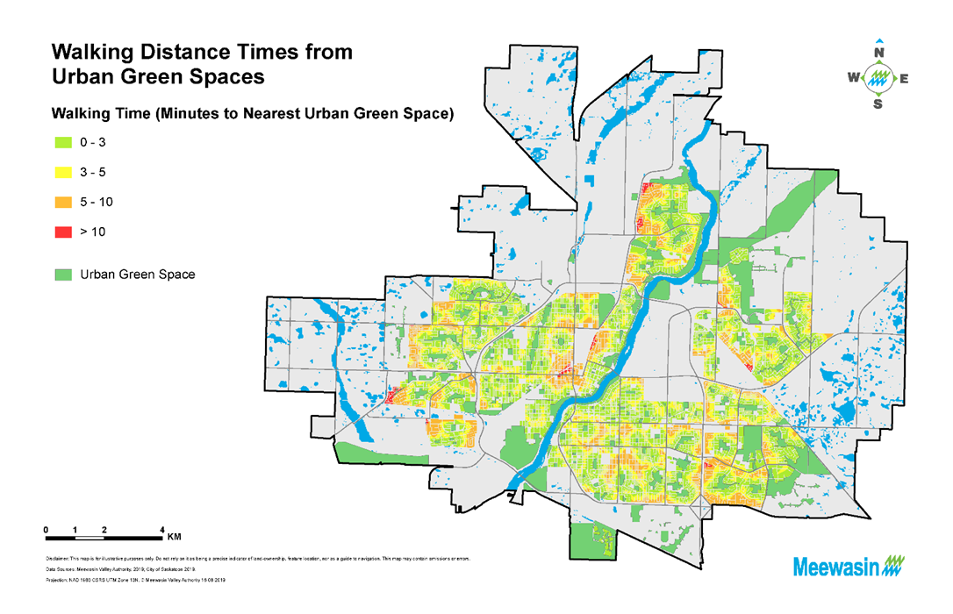

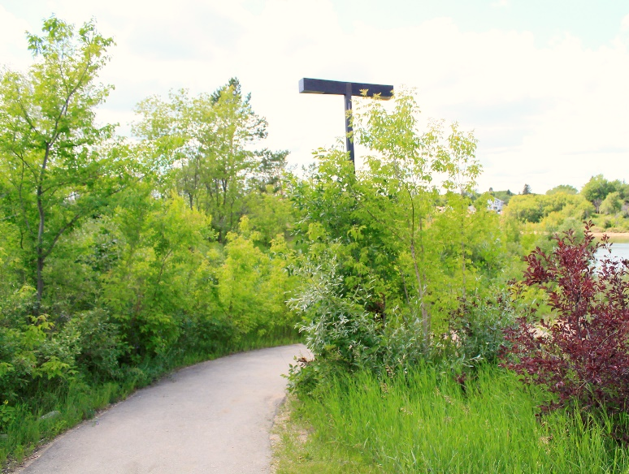
The Natural Areas Inventory Report was completed to assess the existing Green Network in the City of Saskatoon. It is intended to provide baseline data regarding Saskatoon’s Natural Assets (Aquatic, Forested & Shrub land, Grassland) and Enhanced Assets (Green Space and Agricultural Lands). It also analyzes species observations and cultural significance within the Green Network. The Natural Areas Inventory builds upon the success of Meewasin’s State of the Valley Report, which focuses on the entire Meewasin Valley. The Natural Areas Inventory was identified as a key action in the Meewasin Valley-wide Resource Management Plan. https://meewasin.com/wp-content/uploads/2019/12/Natural-Areas-Inventory-for-the-City-of-Saskatoon-2019-Final-Report-November-25-2019.pdf
Meewasin and You Keeping It Green!

Meewasin is empowered by the Meewasin Valley Authority Act to coordinate or control the use of development, conservation maintenance and improvement of land development within the conservation zone. It is guided by a statutory committee of professional planners, architects, landscape architects, engineers and geological engineers.

Meewasin is recognized world-wide for its leadership in conserving the natural resources of the 6,700 hectares of the Meewasin Valley. Meewasin sites and areas are home to more than 200 plant species, 100 bird species, and numerous insects, amphibians, reptiles and animals. Meewasin strives to protect and enhance biodiversity in the Meewasin Valley through targeted conservation grazing, prescribed burns, removal of exotic invasive species and noxious weeds, native seed collection and planting of native grasses and wildflowers and clean-up of illegal dumping. https://meewasin.com/conservation/

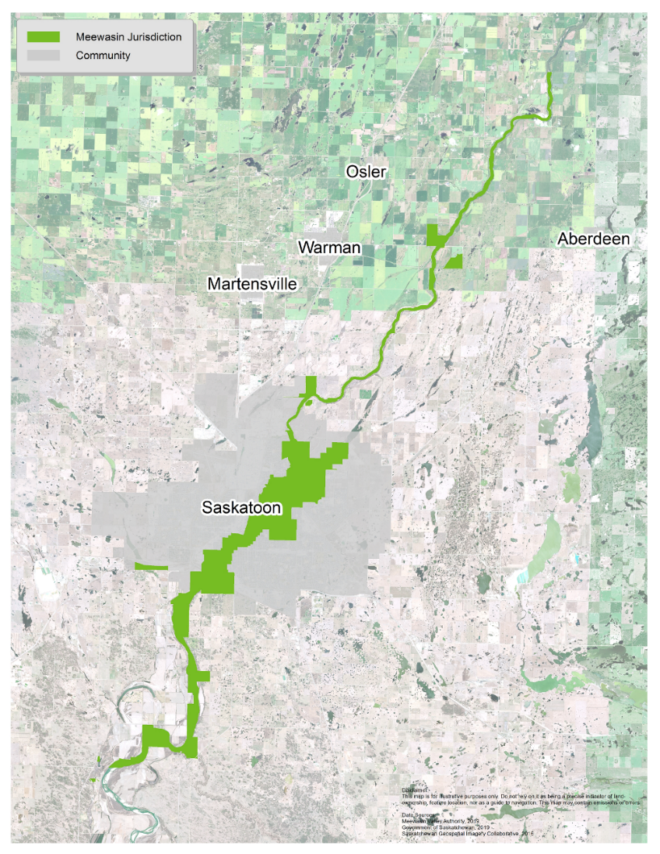
Meewasin Jurisdiction Map

Meewasin’s jurisdiction centres in Saskatoon and runs approximately 80 km along the river valley through the City of Saskatoon and the Municipality of Corman Park from Pike Lake to Clarke’s Crossing. It encompasses conservation areas, parks, museums, interpretive centres, university lands, canoe launches, community links and more than 80 km of Meewasin Trail. Including the South Saskatchewan River there are more than 25 square miles (60 square kilometres) in the conservation zone.
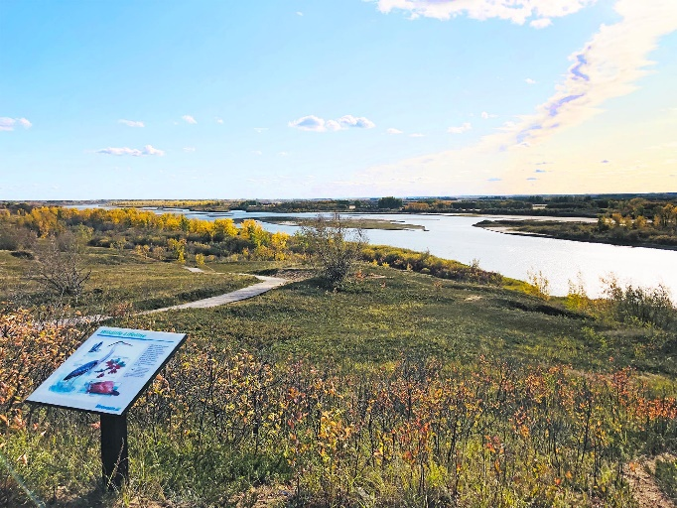
Meewasin Trail – Your Path to Nature

Many parks and sites are located along the Meewasin Trail, a must-see attraction. The trail runs over 90 km along both sides of the river, winding under the bridges, and through beautifully landscaped parks and natural areas. Residents and visitors flock to the trail to cycle, jog, stroll or simply gaze at the scenery. Exploring the trail is easy! Access points are found throughout the city, with maps and interpretive signage along the route. View our Meewasin Trail Guide 2018 for trail map and site information!

Meewasin State of the Valley 2013 Assessment Report
(2018 report coming soon.)

Meewasin’s mission is to “ensure a healthy and vibrant river valley, with a balance between human use and conservation by: providing leadership in the management of its resources; promoting understanding, conservation and beneficial use of the Valley; and undertaking programs and projects in River Valley development and conservation, for the benefit of present and future generations”. The State of the Valley Report is an assessment of outcomes resulting from the approach the Meewasin Valley Authority takes to stewardship of the natural and cultural heritage resources of the Meewasin Valley. The report represents a snapshot of the Valley in 2013 and reflects trends since 1993. https://meewasin.com/wp-content/uploads/2019/11/State-of-the-Valley-2013.pdf

Taking Your Learning Experience to the Out-of-Doors

Welcome to my Ecosystem.

The word ecosystem combines two words: ecology and system.

Eco, the household of nature, and system, a set of interactions over time among living and non-living elements of the household.

When students ask questions about how terrestrial and aquatic ecosystems work, teachers do not need to be professional ecologists. Many books and articles have been written in the field of ecology. Through print and digital formats, a large amount of resource material is available to teachers and students.

Some resources to consider;

Hinterland Who’s Who

This is where you’ll find an incredibly wide range of information on an incredibly wide range of species in Canada, including those that are at risk. Exactly how wide? Oh, about 5 514 kilometres . . . which just happens to be the width of Canada from coast to coast.
https://www.hww.ca/en/wildlife/

Sharing Nature - Nature Awareness Activities for all Ages

Sharing Nature with Children® sparked a worldwide revolution that connected millions of parents, educators, and children with nature. This classic has now been combined with Sharing the Joy of Nature to make a treasury of Joseph Cornell’s best-loved nature games.
https://www.sharingnature.com/sharing-nature.html

Project Wild Canada
Project WILD is based on educational standards, developed by scientists, and reviewed and field-tested by educators. The interdisciplinary Canadian Project WILD guide features 121 complete lesson plans about wildlife and the environment that can each be adapted for any age, grade level or subject.
https://cwf-fcf.org/en/explore/wild-education/project-wild.html

Why am I standing out here?

Having students study ecology helps them to develop an awareness and understanding of relationships. The ability to see systems, sets of interactions, thinking about how they have changed, and might still change with time. Living systems are complex with all parts fitting together to make a whole. The removal of one part can result in major consequences.

A dead leaf floating on the surface of a pond might be seen as insignificant. By drawing connections in as many directions and dimensions as possible it is discovered that the leaf is food, habitat, a former trap for the sun’s energy, nutrients in decomposition. A simple dead leaf is part of the system and a greater awareness of living systems is created in the student.

Why am I standing in the same spot I was standing in three months ago?

It can be a powerful experience for students to visit and revisit a natural setting in each of the four seasons of the year. Seasonal changes are important to the economy of nature. Ecosystems change overtime. The changes of the seasons are an important phase in the continuing natural change in natural systems.

If the opportunity presents itself, have students follow an ecosystem throughout the seasons from late summer to fall. Through winter and into spring and summer.

- What are the plants in the area? How do animals make use of them? What happens to the plants as seasons change? How do animals respond to the change in the plant community?
- Who hibernates, migrates, or remain active because of the change in seasons?
- How do we play a role to ensure that ecosystems remain healthy and viable?

Having students study ecology helps them to develop an awareness and understanding of living and non-living systems and their relationship to these systems.

Loaded with knowledge of an ecosystem and a student audience standing in a habitat, it would be suggested to utilize an interpretive program delivery method to create an engaging experience.

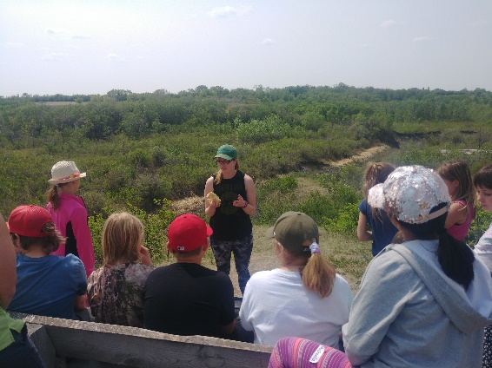
Interpretive Program Delivery

"Interpretation is a communication process, designed to reveal meanings and relationships of our cultural and natural heritage, through involvement with objects, artifacts, landscapes and sites." - Interpretation Canada.

What is the difference between information and interpretation?

Information presented to visitors is just that, straight facts, figures and dates. A field guide to birds provides “information" about the bird species, but usually no interpretation. But all interpretation contains information. Interpretation is not what you say to visitors, but rather the way you say it to them. - John Veverka & Associates

Freeman Tilden - The Father of Heritage Interpretation

https://www.savedbynature.org/post/freeman-tilden-the-father-of-heritage-interpretation-people-of-the-parks-past-series-8

Freeman Tilden (August 22, 1883 – May 13, 1980) is known as the Father of Heritage Interpretation and lived to be 97 years old. Tilden was the first author to ever provide a definition for the field of interpretation: “An educational activity which aims to reveal meanings and relationships through the use of original objects, by firsthand experience, and by illustrative media, rather than simply to communicate factual information.” He’s famous for writing the book Interpreting Our Heritage in 1957. In this book he laid down the principles and theories of park interpretation that would inspire interpreters across the world for future generations to come.

As an employee of the National Park Service his responsibilities included traveling to numerous National Parks so he could observe and record the presentations and habits of Park Rangers as they delivered educational programs to visitors. He complied these notes and began to lay the foundation for interactive, provocative interpretation. In his studies lie the ingenuity of high-quality pioneers, people who were educating in engaging ways before the book was even written. These were his study subjects, he took what he seen that worked, and created a compilation of techniques and principles.

Today Freeman is an icon for interpretation and his book Interpreting Our Heritage is held in high regards. Freeman’s most famous quote, “Through interpretation, understanding; through understanding, appreciation; through appreciation, protection.”

Tilden’s 6 Principles of Heritage Interpretation

- Any interpretation that does not somehow relate what is being displayed or described to something within the personality or experience of the visitor will be sterile.

- Baseball bats are made from ash trees. Young children play baseball. Next time you’re holding a bat you can think of this ash tree.
- Varying age groups use hand tools and kitchen implements. Different birds have different beaks to acquire specific food. Some beaks are like needle nose pliers, some like heavy weight pliers, some like straws, some like colanders or strainers. Using the tools demonstrate the food source that the related bird would be sourcing.

- Information, as such, is not Interpretation. Interpretation is revelation based upon information. But they are entirely different things. However, all interpretation includes information.

- “This is a willow tree.” You have been factual, but this statement alone will not engage the student.
- “I have a head ache and I’m out of aspirin.” (show empty aspirin bottle) “How could this willow tree help me?”
- Willow Bark Aspirin - Willow bark comes from the willow tree of the Salix species. The bark contains salicin, a compound similar to aspirin. Salicin is metabolized in the body to create salicylic acid, a precursor to aspirin. The herbal extract has long been used in native and folk medicine to relieve pain, inflammation, and fever.

- Interpretation is an art, which combines many arts, whether the materials presented are scientific, historical or architectural. Any art is in some degree teachable.

- In one program delivery you may be a teacher, an actor, or story teller.
- When out in the field you can use a collection of natural artifacts, props, and puppets to create a story of a year in the life of a particular animal.
- As a guide in a historic home you could dress in period costume and speak in the voice of a servant who worked in the home during an important time in the story of the historic site. You could relate a story that happened to the family who lived there that reveals more about their lives. You could sing a song from the period that expresses the feelings that the family might have experienced.
- These artistic approaches are powerful in connecting with people rather than a purely narrative tour.

- The chief aim of Interpretation is not instruction, but provocation.

- Your role is to help change attitudes and behavior, to motivate, to inspire, to take information and make it meaningful, interesting, and exciting.
- An objective is to take the visitor through the process of sensitivity – awareness – understanding – appreciation and finally commitment.

- Interpretation should aim to present a whole rather than a part and must address itself to the whole man rather than any phase.

- Your program should help students understand that the things they do and see in natural areas are related to what they do and see at home in their everyday lives.
- While at a beaver pond you show the group a stump with obvious chew marks made by a beaver. You explain that a beaver did the gnawing. The group might be fascinated or they might yawn—a beaver, so what?
- Instead, you tell the story of how beaver ponds formed by the cutting and damming of tress create aquatic ecosystems used by dozens of animal species for food and habitat. You relate the water cycle of creek and river systems to the water system in Saskatoon and explain that the engineers (beavers) in the wild play as vital a role as the hydrologist and engineers at our domestic water treatment plant. This approach tells the bigger story behind a beaver-gnawed stump and relates it to people who live in the city.

6. Interpretation addressed to children (say up to the age of twelve) should not be a dilution of the presentation to adults but should follow a fundamentally different approach. To be at its best it will require a separate program.

- When you show adults the Northeast Swale, you talk about the ecosystem and ask them to look at the beaks and feet of birds and discuss what the birds might eat with those kinds of tools to acquire food—an intellectual exercise. With a children’s group, you would ask the kids to demonstrate how birds walk, the sounds they make, and then have them try to guess why the varied walks and sounds help them survive. Playing games that engage an active imagination and allow acting things out is effective with children. The same activity with a group of adults might fall flat. Learning styles change as people mature and good guides and interpreters employ different strategies with people in different age groups.

In addition to his six principles, Tilden also said, “Le style, c’est l’homme.” It is the person, the guide, the interpreter who makes something special happen. It is delivery with style and enthusiasm that works best. Each interpreter has to find his/her own special voice. Therein lies the art of interpretation, applying the scientific principles of interpretation to help audiences make emotional and intellectual connections with meanings inherent in the resources.

Use the out-of-doors as a natural classroom.

- Start by bringing the outdoors indoors by growing plants and building terrariums.
- Visit your school grounds and discover that natural living systems are everywhere … even in the crack of the sidewalk.
- Walk around the school block and observe the variety of habitats created by urban development.
- Who’s living in your neighborhood?
- What can you do to help your wild neighbors?

Environmental Stewardship

Environmental stewardship refers to responsible use and protection of the natural environment through conservation and sustainable practices. Aldo Leopold (1887–1949) championed environmental stewardship based on a land ethic "dealing with man's relation to land and to the animals and plants which grow upon it."

A Stewardship Horizon

Stewardship planning is long term. For example, forests can take generations to grow and mature. That’s why a 20-year planning horizon is recommended. It will take at least 10 years for many projects to evolve and for you to be able to see the results of your efforts. When enjoying any natural area remember that what you are experiencing today will grow and mature over time and continue to provide a lifetime of discoveries for yourself and others.

Meewasin asks you to think and act responsibly;

- Just by walking over fragile areas or observing animals under certain conditions, we can destroy or disturb organisms.
- Pay attention to the consequences of your actions.
- Encourage thoughtful decision making and responsible behavior.
- Obey all laws protecting plants and animals.
- Do not collect anything unless you have written permission.
- Do not leave any garbage.
- Pick up after others if safe to do so.
- Report any wonderful experiences you have to MEEWASIN.
- Report any problems you see or experience to MEEWASIN so the issue can be addressed accordingly.

I have a school ground. What’s in it?

To book an Interpretive Program Development session for your school delivered by Meewasin Education & Experiences program staff please contact _________________________ .

Meewasin Valley Authority
402 Third Avenue South
Saskatoon, Saskatchewan S7K 3G5
Phone: 306-665-6887
Email: meewasin@meewasin.com
Web: www.meewasin.com

